

**PES University, Bangalore**

(Established under Karnataka Act No. 16 of 2013)

**UE21EC251B- DIGITAL VLSI DESIGN(UE21EC251B)**

**DVLSI- PROJECT**

Session: Jan-May 2023

**Branch: ELECTRONICS AND COMMUNICATION ENGINEERING**

**Semester &Section:4TH SEM , A SECTION**

|  |  |  |  |
| --- | --- | --- | --- |
| **Sl No.** | **Name of the Student** | **SRN** | **Marks Allotted**  **(Out of 5)** |
| 1. | AKASH RAVI BHAT | PES1UG21EC025 |  |
| 2. | ABHISHEK A. SHETTY | PES1UG21EC008 |  |
| 3. | ANIKETH JOSHI | PES1UG21EC039 |  |

Name of the Course Instructor : **Prof. ANNAPURNA K. Y.**

Signature of the Course Instructor

(with Date) : ___________________________

TOPIC:- **BCD(BINARY CONVERTED DECIMAL) COUNTER**

**INTRODUCTION**

* + A BCD (Binary Coded Decimal) counter is a type of counter that counts from 0 to 9 in binary-coded decimal format. Each digit in the counter represents a binary number from 0000 to 1001. When the counter reaches 1001 (9 in decimal), it resets to 0000 and continues counting again.
  + The BCD counter circuit can be implemented using various digital logic circuits such as D flip-flops, JK flip-flops, and synchronous counters.

The BCD counter project can be used in various applications such as digital clocks, electronic meters, and scoreboards. It is a fundamental building block in digital electronics and serves as an essential component in many circuits

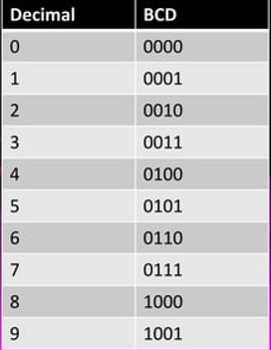

**BACKGROUND AND APPLICATIONS OF BCD COUNTER**

* BCD counters are widely used in digital circuits where it is necessary to count and display decimal numbers. They are commonly used in applications such as digital clocks, calculators, and other electronic devices that require precise decimal counting.
* The basic structure of a BCD counter consists of a series of flip-flops, each of which represents one digit of the BCD code. The input to each flip-flop is taken from the output of the previous flip-flop, and the output of the last flip-flop is fed back to the input of the first flip-flop to create a feedback loop.
* **TYPES OF BCD COUNTERS**
* **There are two types of BCD counters:**
* **Synchronous BCD counters are controlled by a clock signal and all flip-flops change state simultaneously.**
* **Asynchronous BCD counters do not require a clock signal and change state sequentially as the input signal changes.**

**BCD counters are also available in different configurations, such as up counters and down counters, which count up or down, respectively. They can also be designed to count to specific values, or to reset to zero after a certain count is reached**

**SCHEMATIC DIAGRAM OF BCD COUNTER USING D FLIP FLOP**

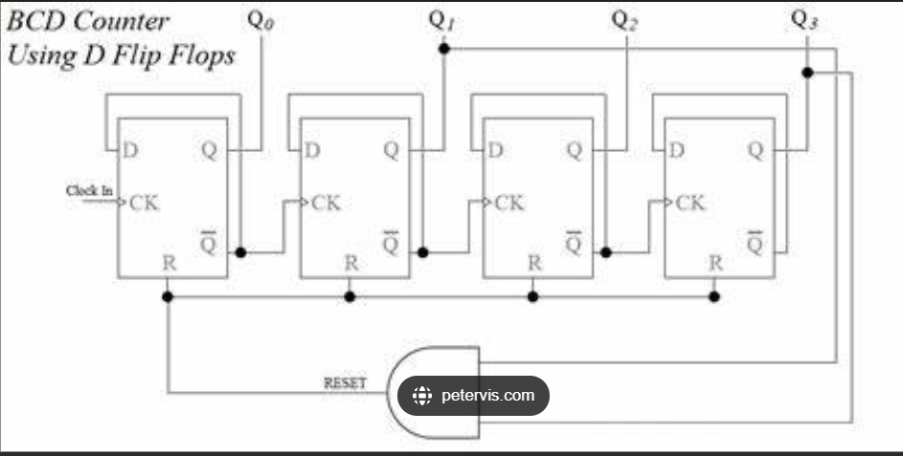

**SIMULATION USING VIVADO**

* CODE:-
* module VLSI_PROJECT(clk,rst,count);
* input logic clk,rst;
* output logic [0:4]count;
* always@(posedge clk,negedge rst)
* if(rst)
* count<=0;
* else
* count<=count+1;
* endmodule

**VIVADO TESTBENCH CODE**

* module VLSI_PROJECT_tb();
* reg clk,rst;
* wire [0:4]count;
* VLSI_PROJECT dut(clk,rst,count);
* initial begin
* clk=0;
* rst=0;
* end
* always #5 clk=~clk;
* always #80 rst=~rst;
* endmodule
* **SIMULATION OUTPUT**

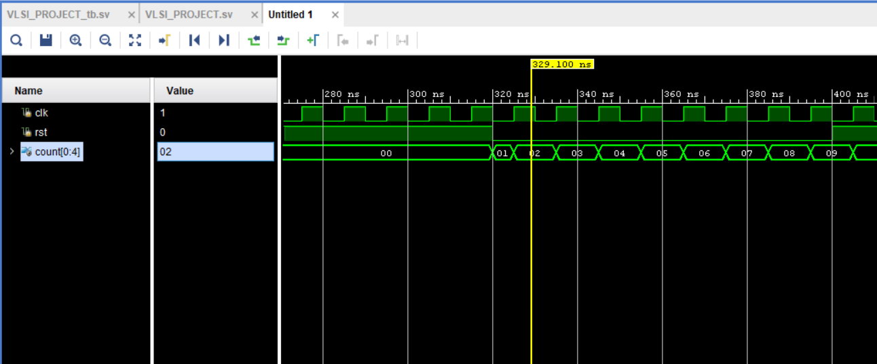

**CONCLUTION OF SIMULATION**

* BCD counter counts in binary coded decimal (BCD) format, which means that each decimal digit is represented by a binary code of 4 bits.
* For example, a 4-bit BCD counter can count from 0 to 9 and then reset to 0.
* In a BCD counter, the reset becomes 0 after the counter has reached its maximum count value, which is 9 in decimal, or 1001 in BCD binary code. Once the counter reaches 9, it resets back to 0, and the counting sequence starts over again.
* The output of a BCD counter can be displayed using LEDs or other output devices, depending on the design and purpose of the counter. It can also be used in conjunction with other circuits or devices to perform various functions, such as timing, control, or data processing.

**BCD TO SEVEN SEGMENT DECODER**

* A standard 7-segment LED display generally has 8 input connections, one for each LED segment and one that acts as a common terminal or connection for all the internal display segments. Some single displays have also have an additional inpu pin to display a decimal point in their lower right or left hand corner.
* In electronics there are two important types of 7-segment LED digital display.1. The Common Cathode Display. (CCD) - In the common cathode display, all the cathode connections of the LED's are joined together to logic "0" or ground. The individual segments are illuminated by application of a "HIGH", logic "" signal to the individual Anode terminals.2. The Common Anode Display (CAD) - In the common anode display, all the anode connections of the LED's are joined together to logic "" and the individual segments

**NECESSARY MATERIAL**

* **R1 - 100K Ohm**
* **• R3 - 330 Ohms**
* **• R4 - 100 Ohms**
* **• C1 - 10 Uf**
* **• IC1 - 555 Timer**
* **• IC2 - 4518 BCD Counter (4520 may be used)**
* **• IC3 - 4511 BCD to 7 Segment Decoder**

**• 4 LEDs**

* **• 7 Segment Display (Common Cathode, Radio Shack #276-75)**
* **• +V9 volts**

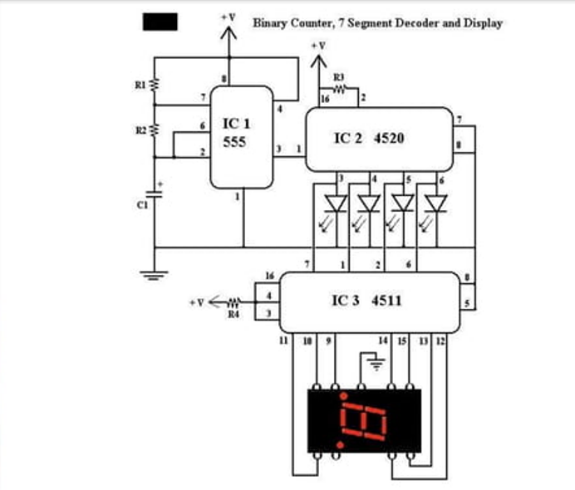

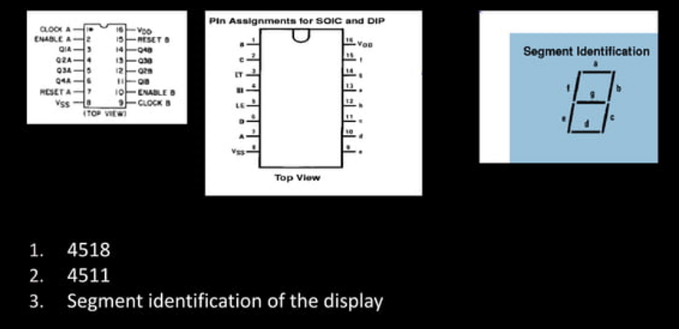

**OVERALL CONCLUSION**

* Many Important Applications Of BCD:>>>>The Atari 8-bit family of computers used BCD to implement floating-point algorithms. The MOS 6502 processor used has a BCD mode that affects the addition and subtraction instructions.
* »» Early models of the PlayStation 3 store the date and time in BCD. This led to a worldwide outage of the console on 1st march 2010. The last two digits of the year stored as BCD were misinterpreted as 16 causing a paradox in the unit's date, rendering most functionalities inoperable

**REFERENCE:**

"Digital Electronics: Principles, Devices and Applications" by Anil K. Maini - This book provides an introduction to digital electronics and covers BCD counters and other related topics.

"Digital Design: Principles and Practices" by John F. Wakerly - This book provides a comprehensive introduction to digital design and covers BCD counters and other related topics.

"Introduction to Digital Systems" by Milos Ercegovac and Tomás Lang - This book covers the fundamentals of digital systems and includes a chapter on BCD counters.

"Electronics For You" magazine - This is a popular electronics magazine that covers various topics related to digital electronics, including BCD counters.

"All About Circuits" website - This website provides a wealth of information on electronics and includes a section on digital circuits, which covers BCD counters.

**THANK YOU!**